Homework 4

Please review the Sample Format for HW4 & HW5 and organize your submission similarly.

SQL Exercises

Based on the SQL script file for Pine Valley Furniture Company, write the SQL statements for the following queries.

1. List all customers:

SELECT*FROM S_Customer_T;

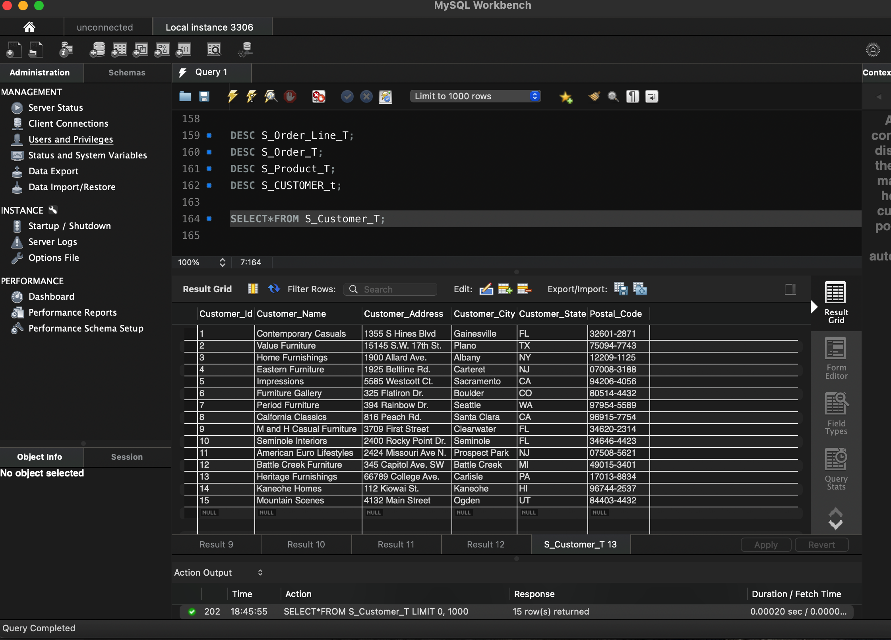

1. What is the address of the customer named Home Furnishing? Use Alias, Name for customer name?

SELECT CUSTOMER_ADDRESS AS Address, CUSTOMER_NAME AS Name

FROM S_Customer_T

WHERE CUSTOMER_NAME = ‘Home Furnishings’;

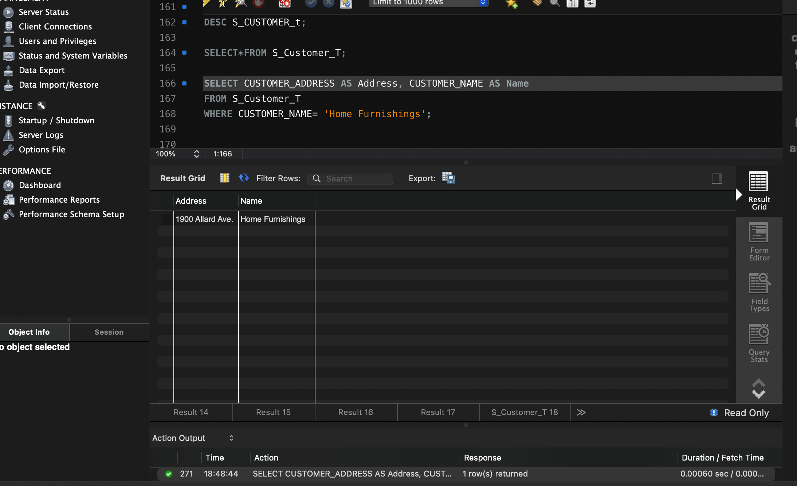

1. Which product has a standard price of less than $200?

SELECT*

FROM S_Product_T

WHERE STANDARD_PRICE < 200;

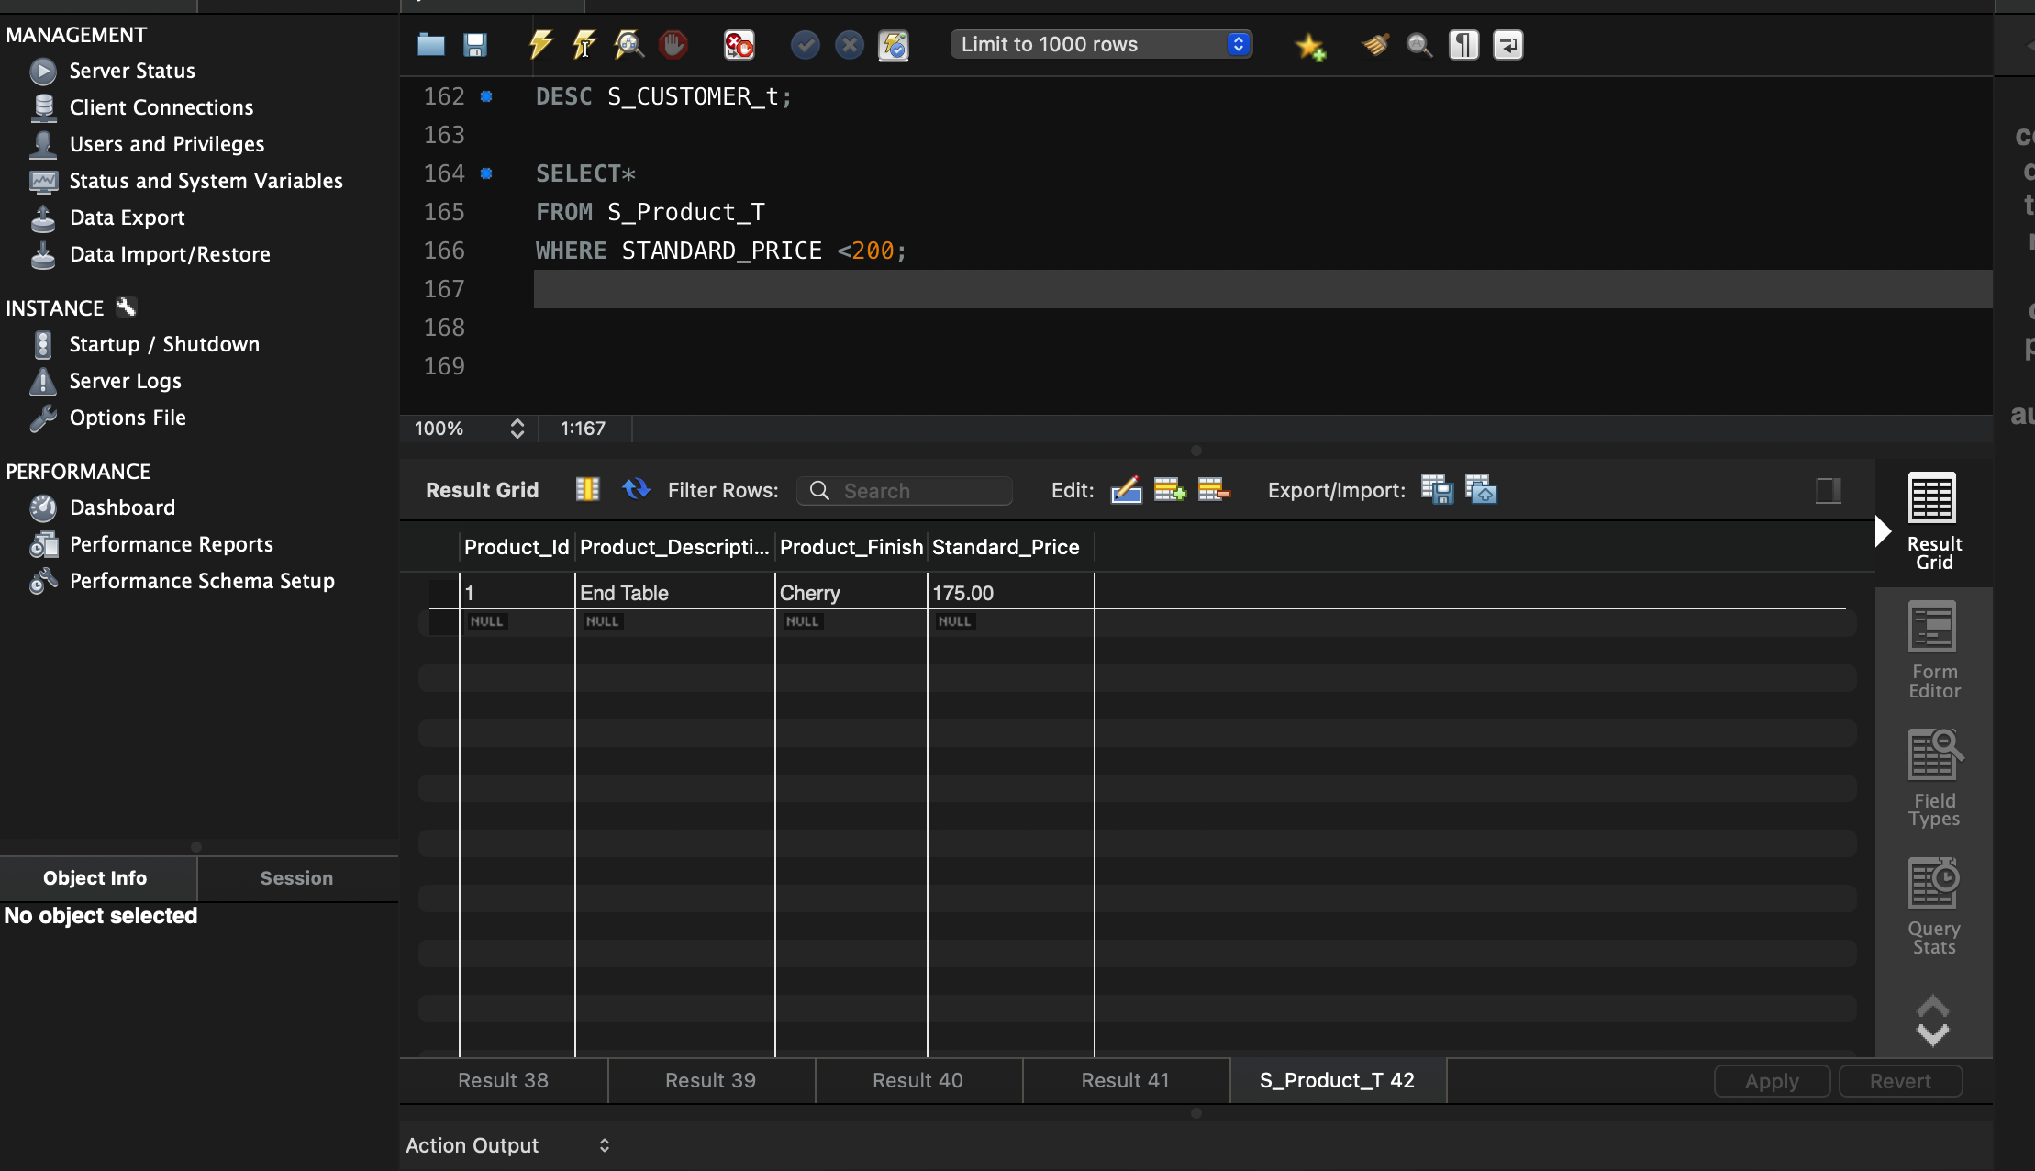

1. What is the average standard price of products?

SELECTAVG (STANDARD PRICE) AS Average_Standard_Price

From S_Product_T;

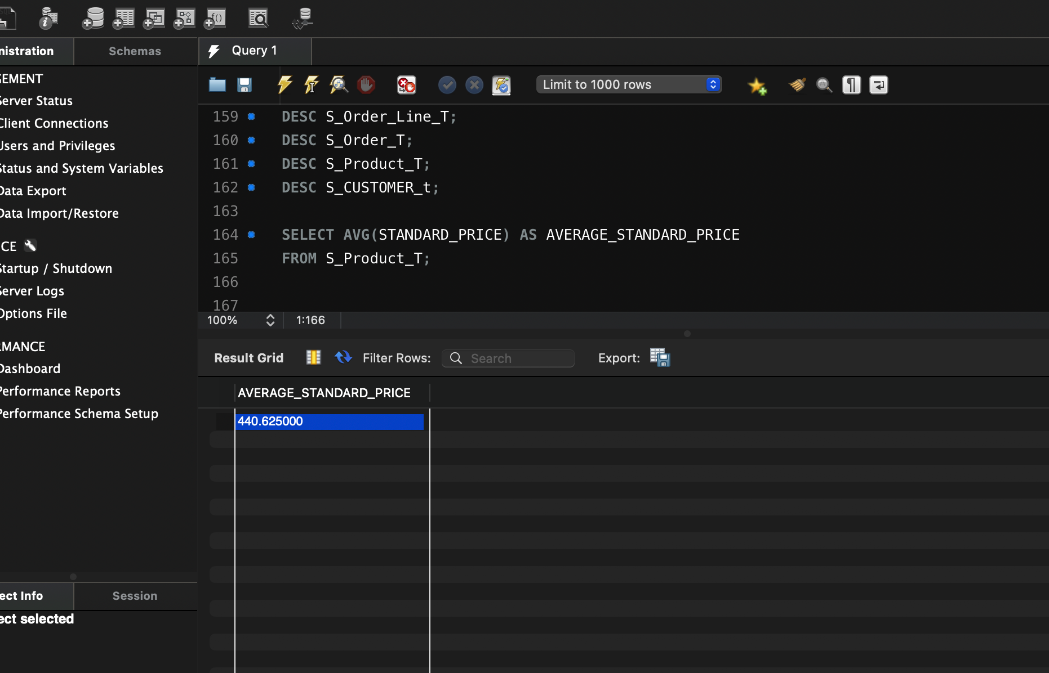

1. What is the price of most expensive product in inventory?

SELECT MAX(Standard Price) AS Max_Standard_Price

FROM S_Product_T;

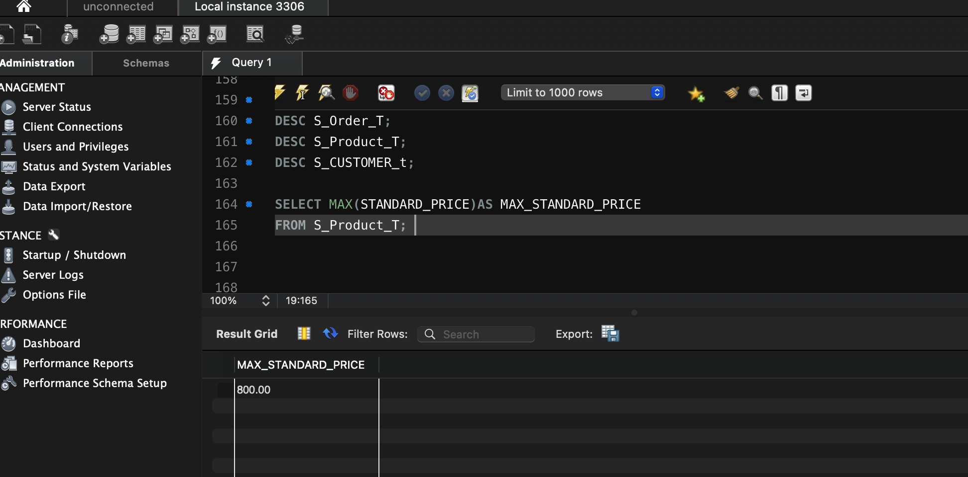

1. Count all orders:

SELECTCOUNT(*) AS ORDER_COUNT

FROM S_Order_T;

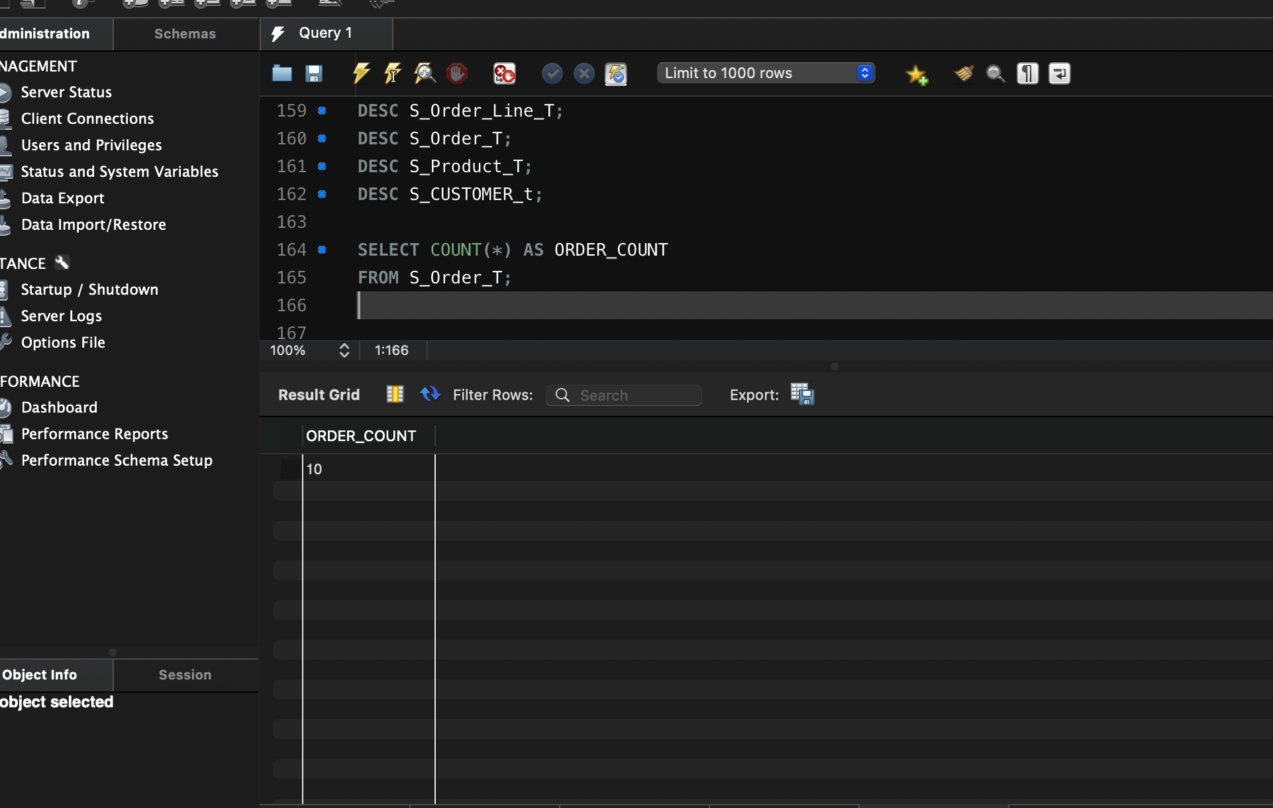

1. How many different items were ordered on order number 1006?

SELECT COUNT(DISTINCT PRODUCT_ID) As Unique_Items_Ordered

FROM S_Order_Line_T

WHERE ORDER_ID = 1006;

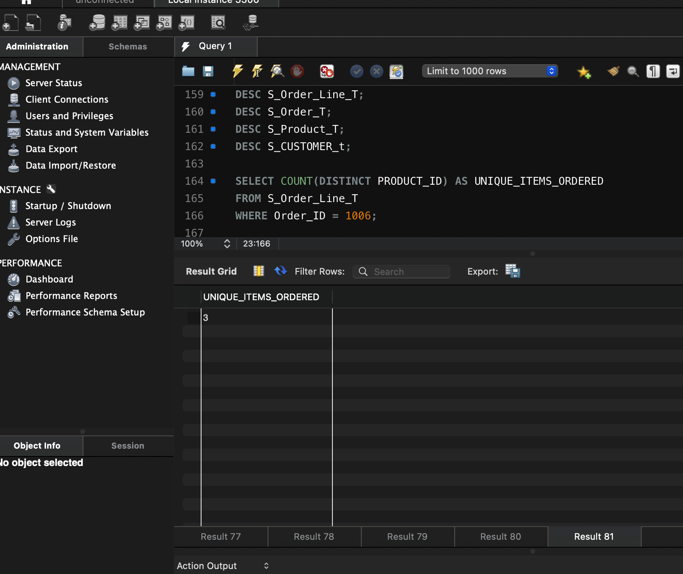

1. Which orders have been placed before 2020-24-10

SELECT ORDER_DATE AS DATE

FROM S_Order_T

ORDER BY DATE < (10/24/2024);

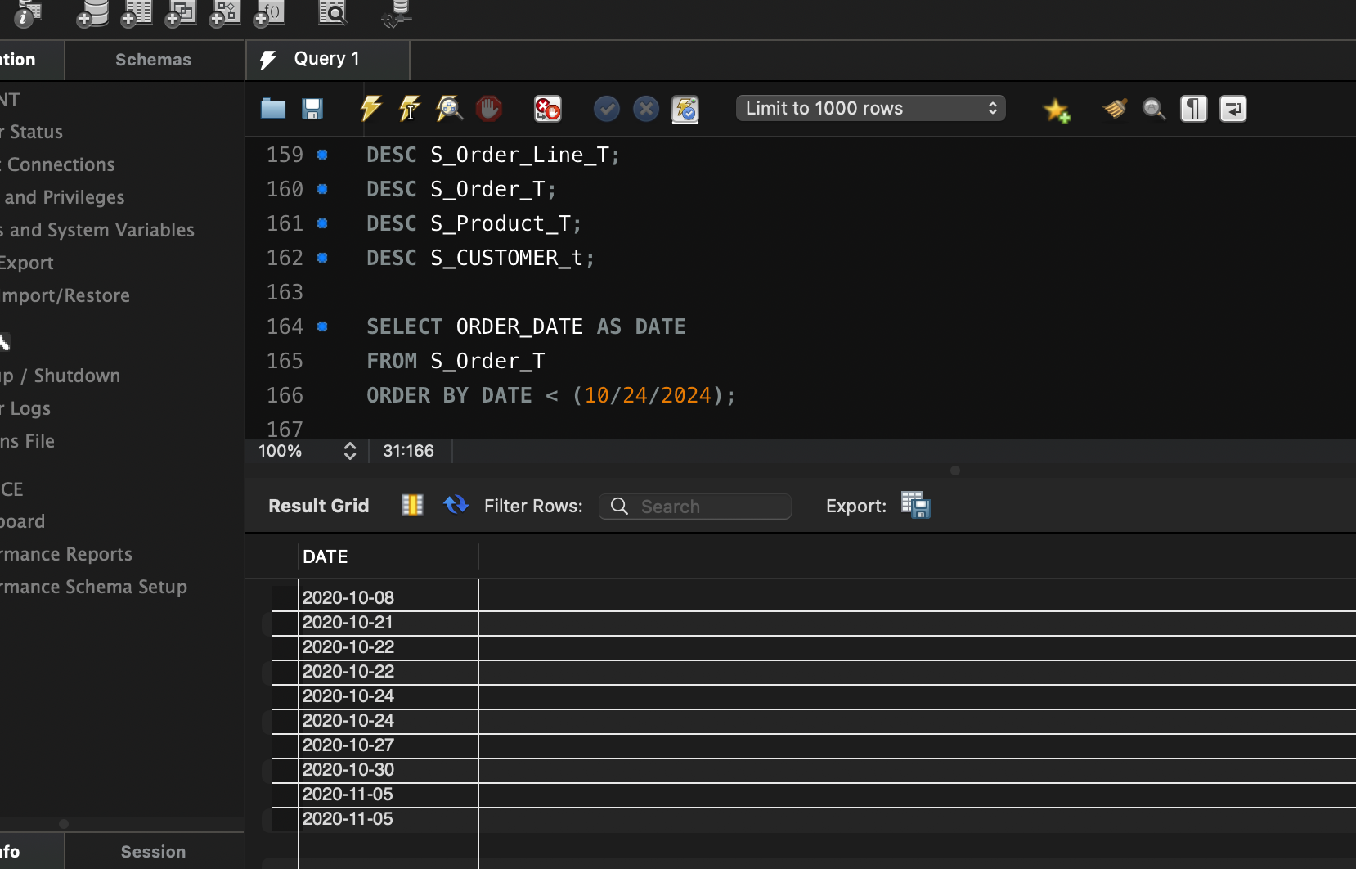

1. Alphabetically, what is the last product name in the PRODUCT table? Use an alias NAME.

SELECT PRODUCT_DESCRIPTION AS NAME

FROM S_Product_T

ORDER BY NAME DESC

LIMIT 1;

